3 Easiest Ways to Find Lost Windows Password

Article Source:

http://recoverlostpassword.com/article/lost-windows-password.html

With the growing security consciousness for modern people, they are busy to remember their bank numbers, names of people, phone numbers, social security numbers and dozens of others things. Who has time to remember their Windows password? But when they lost Windows password, they feel that the world is coming to an end. Don't fret; you can definitely resume access with a variety of techniques.

Here I would like to share some ways to help you find lost Windows password:

- It is smart and cautious for you to create a password reset disk before you lose your Windows password (absolutely NOT after that). You are allowed by Microsoft to create a password reset disk which can be a flash drive or a floppy disk depending on your version of Windows.
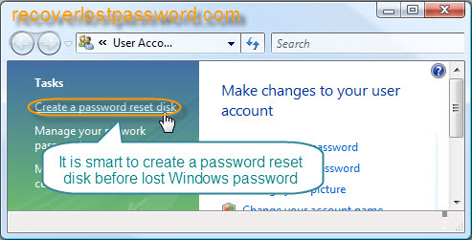
Pros: Free, easy-to-deal, only create disk once no matter how many times you change your password after creating the disk.
Cons: It only works before you lost Windows password. If you never created one by yourself before losing access to Windows, you have to try other method.

- Another way to recover your Windows password is to use the password hint which is at the side of your password prompt on the Welcome screen. According to it, you can try to regain your forgotten password.
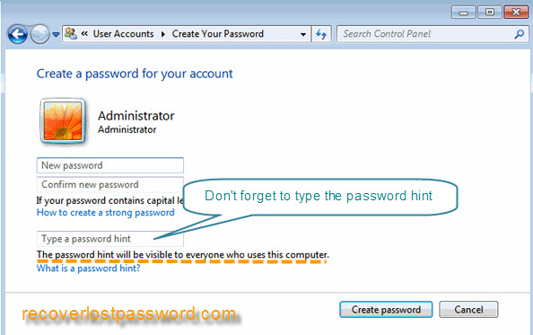
Pros: Convenient, free.
Cons: It often doesn’t work if you have a bad memory.

- The most efficient way is to use the third party software. I have experienced one named Windows Password Recovery. It is fast and easy enough for windows password crackers with a basic knowledge of Windows to recover, or reset lost Windows Password.
Pros: Easy- to operate, convenient, enable you to burn disk after you forgot Windows Password.
Cons: Premium
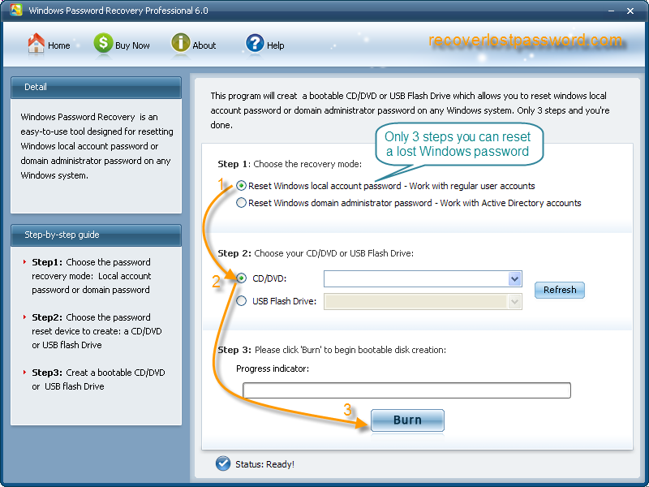
Below is the step-by-step tutorial about how to operate it:

Step 1: Insert a blank CD in another computer that can run as administrator, and download & install & launch Windows Password Recovery.
Step 2: Select the recovery mode you prefer, and tick “CD/DVD” and specify your device.
Step 3: Click “Burn” to create a Windows password reset disk.
Step 4: Boot your computer that can’t access to Windows with CD. You will see Windows Password Unlocker under Win PE.
Step 5: Choose the Windows installation to be processed, and type the new password you desire. And confirm by clicking “Reset”.
Step 6: The reset will be active after you reboot your PC.

Yes, you have retrieved your lost Windows Password successfully. What are you waiting for? Just grab them and share them with your friends.

